Module 10. Building Database Applications with JDBC

The Architecture of JDBC

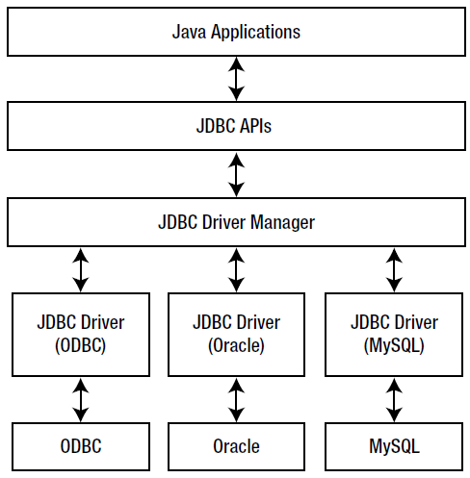

Figure. JDBC architecture

Connecting to a Database Using a JDBC Driver

The Connection Interface

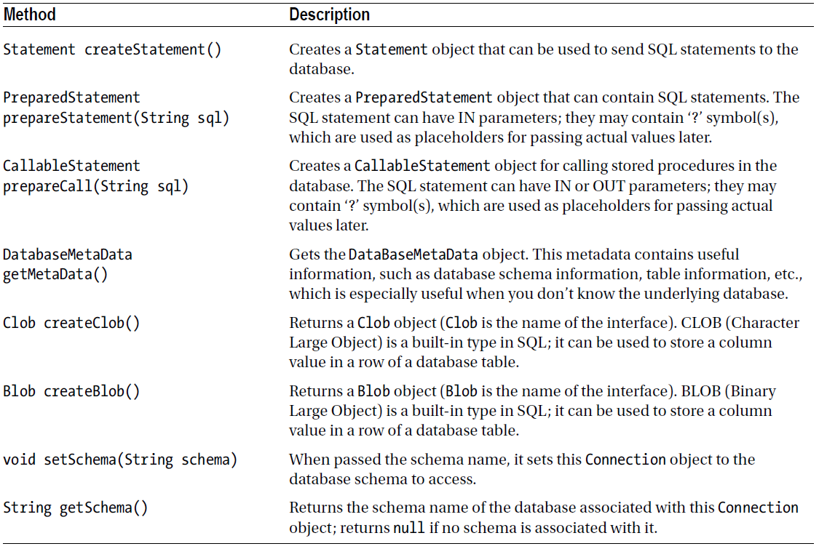

Table. Important Methods in the Connection Interface

Querying and Updating the Database

Statement

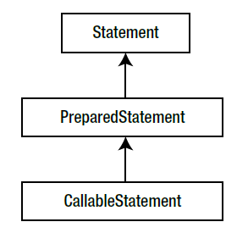

Figure. The Statement interface and its subinterfaces

ResultSet

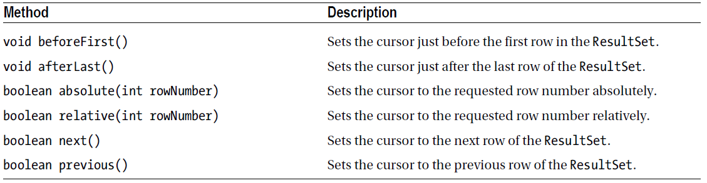

Table. Useful Methods of ResultSet to Move the Cursor

Performing Transactions

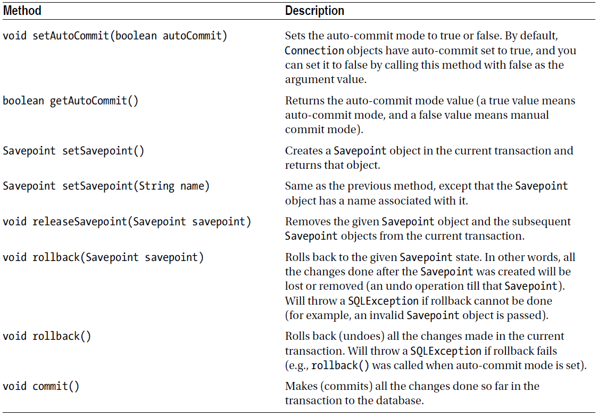

Table. Transaction-Related Methods in the Connection Interface

The RowSet Interface

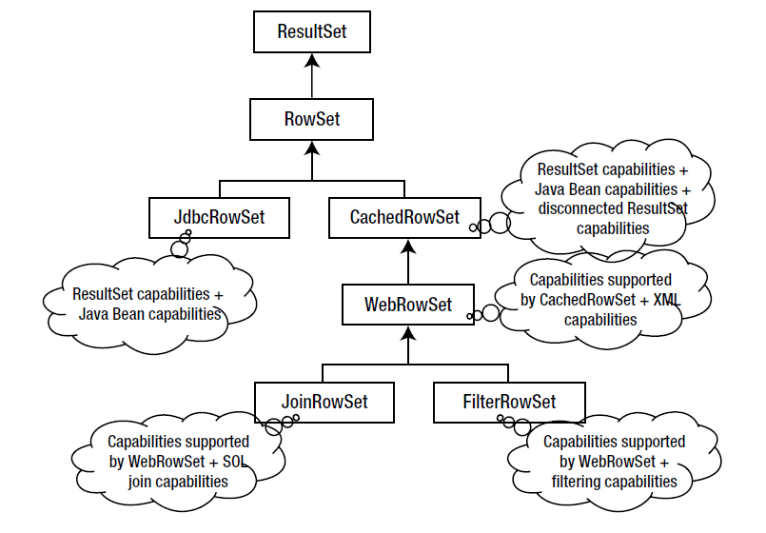

Figure. The RowSet hierarchy

Questions

1. Consider the following code segment. Assume that the connection object is valid and statement.executeQuery() method successfully returns a ResultSet object with a few rows in it.
Statement statement = connection.createStatement();
ResultSet resultSet = statement.executeQuery("SELECT * FROM contact")){
System.out.println("ID \tfName \tlName \temail \t\tphoneNo");
// from resultSet metadata, find out how many columns are there and then read the
column entries
int numOfColumns = resultSet.getMetaData().getColumnCount();
while (resultSet.next()) {
// traverse the columns by index values
for(int i = 0; i < numOfColumns; i++) {
// since we do not know the data type of the column, we use getObject()
System.out.print(resultSet.getObject(i) + "\t");
}
System.out.println("");
}
Which of the following statements is true regarding this code segment?
A. T he code segment will successfully print the contents of the rows in the ResultSet object.
B. T he looping header is wrong. To traverse all the columns, it should be
for(int i = 0; i <= numOfColumns; i++) {
C. T he looping header is wrong. To traverse all the columns, it should be
for(int i = 1; i <= numOfColumns; i++) {
D. T he looping header is wrong. To traverse all the columns, it should be
for(int i = 1; i < numOfColumns; i++) {

2. Assume that you’ve freshly created this table with the following command in MySQL:
create table familyGroup (id int not null auto_increment, nickName varchar(30) Not null, primary key (id));
You’ve written this program that makes use of this table:
import java.sql.Connection;
import java.sql.ResultSet;
import java.sql.SQLException;
import java.sql.Statement;

class DbTransactionTest {
public static void main(String[] args) throws SQLException {
try (Connection connection = DbConnector.connectToDb();
Statement statement =
connection.createStatement(
ResultSet.TYPE_SCROLL_SENSITIVE,
ResultSet.CONCUR_UPDATABLE);
ResultSet resultSet =
statement.executeQuery("SELECT * FROM familyGroup")) {
resultSet.moveToInsertRow();
resultSet.updateString("nickName", "Sam");
resultSet.insertRow(); // INSERT ROW
System.out.println("Table updated with a row. . .");
connection.commit(); // COMMIT STMT
}
}
}
What will be the result of executing this program assuming that establishing the connection succeeds?
A. T he program will successfully insert a row with id = 1 and nickName = “Sam”.
B. A SQLException will be thrown in the line where the INSERT ROW comment is provided because you cannot insert a row on a read-only ResultSet object.
C. A SQLException will be thrown in the line where the COMMIT STMT statement is provided because auto-commit is enabled; hence the commit will fail.
D. T he program will not insert anything into the familyGroup table.

3. Consider the following sequence of operations in a transaction:
// assume that all operations execute in this program successfully without
// throwing any exceptions; also assume that the connection is established
// successfully
connection.setAutoCommit(false);
// insert a row into the table here
// create a savepoint in this transaction here
//insert another row into the table here
//create a named savepoint in this transaction here
//insert the third row into the table here
connection.rollback();
connection.commit();
What will be the effect of this sequence of actions after executing the statement connection.commit()?
A. T hree rows will be inserted into the table.
B. N o rows will be inserted into the table.
C. O ne row will be inserted into the table.
D. T wo rows will be inserted into the table.
E. A ll three rows will be inserted into the table.

4. Which one of the following statements would be needed in JDBC 3.0?
A. Connection connection = DriverManager.getConnection("jdbc:mysql://
localhost:3306/addressBook", "root", "password"))
B. Connection connection = DriverManager.createConnection("jdbc:mysql://
localhost:3306/addressBook", "root", "password"))
C. Class.forName("com.mysql.jdbc.Driver").newInstance();
D. Class.forName("com.mysql.jdbc.Driver").getInstance();

5. Consider this program and choose the best option describing its behavior (assume that the connection is valid):
try (Statement statement = connection.createStatement();
ResultSet resultSet = statement.executeQuery("SELECT * FROM contact")){
System.out.println(resultSet.getInt("id") + "\t"
+ resultSet.getString("firstName") + "\t"
+ resultSet.getString("lastName") + "\t"
+ resultSet.getString("email") + "\t"
+ resultSet.getString("phoneNo"));
}
catch (SQLException sqle) {
System.out.println("SQLException");
}
A. This program will print the following: SQLException.
B. This program will print the first row from contact.
C. This program will print all the rows from contact.
D. This program will report compiler errors.

6. Which of the following two statements are correct regarding RowSets in JDBC?
A. It is possible to use JdbcRowSet as a JavaBeans component.
B. WebRowSet provides result set in the JSON format.
C. The filter in a FilteredRowSet object is set at the time of its creation; a filter cannot be set once the FilteredRowSet object is created.
D. A CachedRowSet object caches data in its memory, which makes it possible to use the CachedRowSet object without always being connected to its data source.

